So we are going to proceed with the first demonstration here. Basically, Teacher is going to do after each segment is do a little demo on how you can use the skills that we have just gone over to make something either an object or a scene(group of all objects you have made) in blunder. teacher won't be doing too much lecturing or talking or narrating over this part as it's mostly just to watch and follow along Teacher will, of course, have my keystrokes being captured down in this bottom corner (in the lesson video )so you can follow along with what Teacher is doing. But this part is just for demonstration. Follow along, or use those skills to make something of your own. But without further ado, let's get started.

So we are starting from this default blender scene.

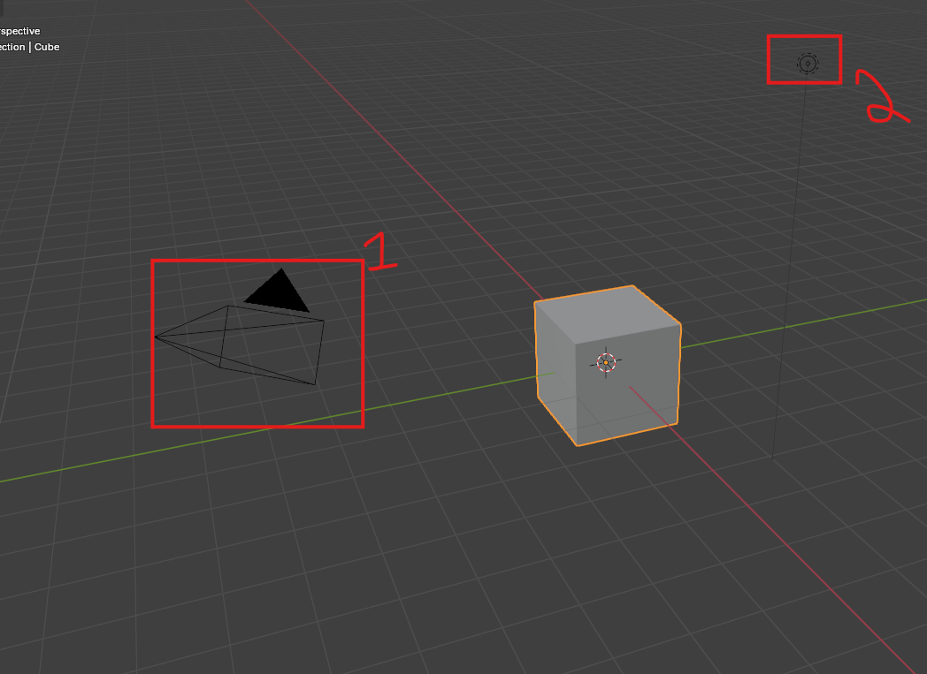

When you open it up, you have a general template. So the first thing we are going to do is just select the camera, delete it as marked 1 above and also delete light marked 2. Just because we're not going to be using them. And actually Teacher is going to delete this cube as well, and I think Teacher os going to start with a different object. So they're a little bit in the way. So now our scene will look like below

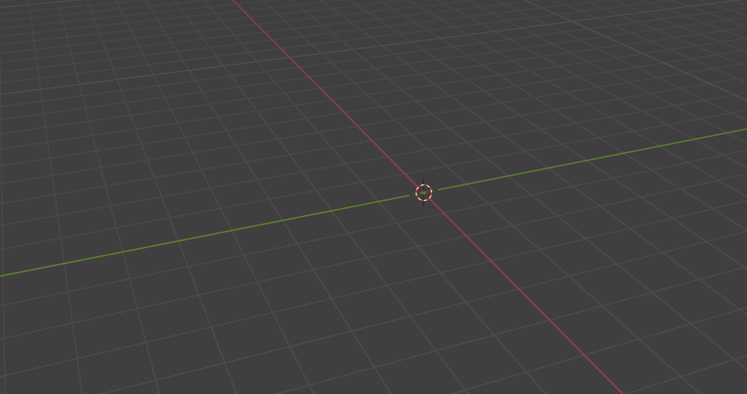

Now add a cylinder by **shift+a** -> Mesh -> cylinder

Now you can see the that the cylinder is added as shown bekiwas our 3D cursor was at the center

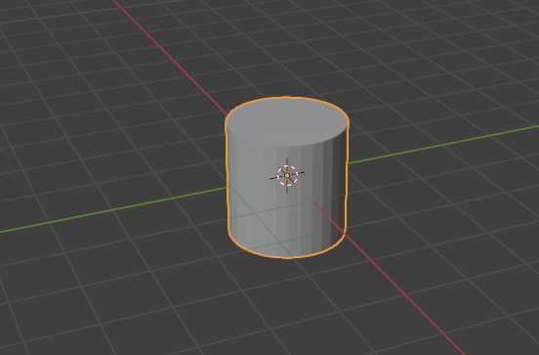

Let's start with the cylinder.

1:21

Now, this is largely just going to be a function of what do we want to make with this? I'm thinking of making maybe like a little a little scene, so, like a like a cartoonish scene. Let's make a tree and let's move this up so that the bottom is sitting on this x axis line.as shown below

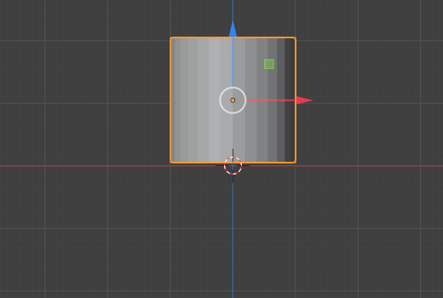

Now, this is going to be our trunk, but it's a little too thick at the moment. So we're going to make this thinner, but not shorter by pressing S and shift Z to lock the Z value. Now it will look like below

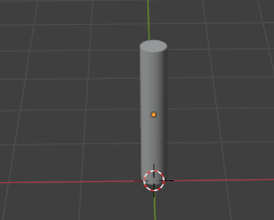

That's pretty good. So we're going to press s and then z to scale only along the z axis and now it will look like below

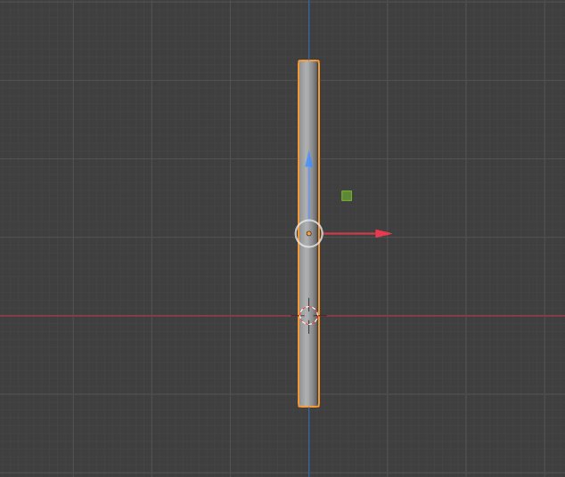

So lets move the cylinder along the x to move it above it now it will look like below

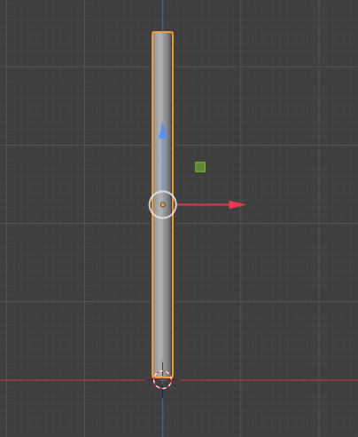

So this is a pretty good trunk. So now we want to do some like sort of like rounded, bulbous C branch clusters, sort of like you'd see in the background of a cartoon.

let's set one to go into front orthographic mode by pressing numpad 1 just because it's going to be a little bit easier to work with. we can shift + right click to move the 3D cursor closer to where we want them. So I place it in the top of our cylinder as shown below

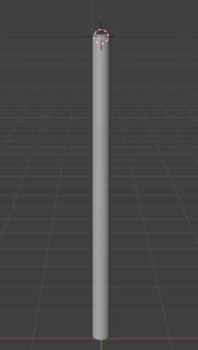

Now we add a sphere now it look like below

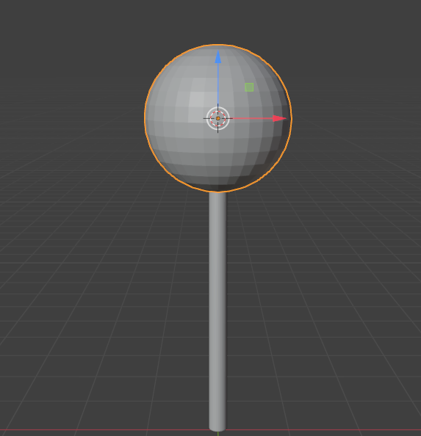

We will make the sphere slightly smaller as shown below

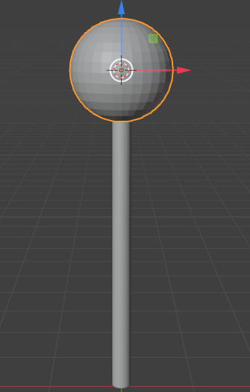

Now we click on numpad 3 to go to right orthographic view

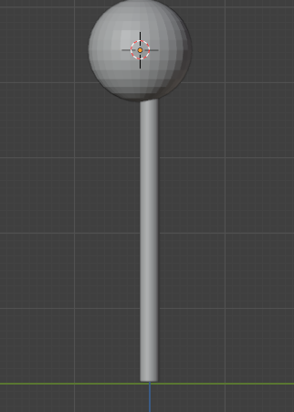

because this is just a little bit farther forward than teacher would like. teacher want it to be as close as I can to exiting exactly on top of this cylinder. So press g for grab to move it Just select this center edge that you can sort of see here is lined up fairly closely with this axis line as marked below

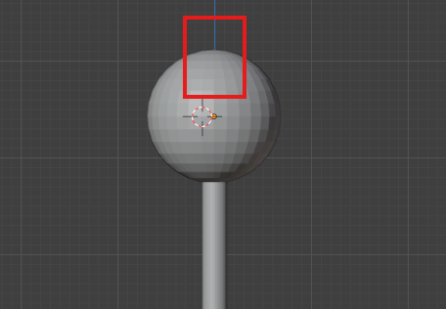

It doesn't have to be exact. It is organic after all. So now to make this a little bit more tree like we're going to scale Z, just flatten this out, just a touch as shown below

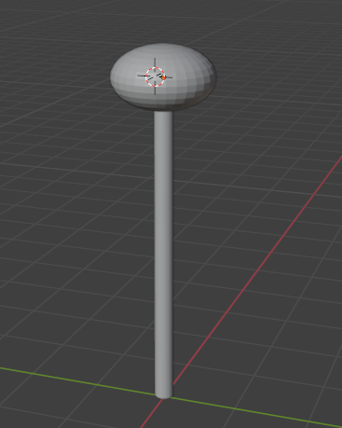

Now, I don't really want these facets and on any of this sop select both the cylinder and then sphere and then do shade smooth so the flat faces are not visible as shown below

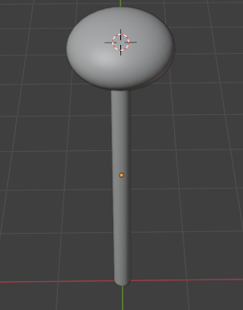

So now when we duplicate from these objects, the objects that we duplicate off of them will be smooth so press shift + d to duplicate it. So now it's just kind of a matter of arranging these objects so that they look somewhat sort of tree It basically means that we duplicate the spheres such that they coincide with each other so they look like a tree So we do sine modification To make it more like a tree you can increase the size of sphere , rotate it just make it look like a tree such that its leaves part look like a tree in cartoon

5:50

Now we duplicate the trunk to make branches from it we rotate the duplicated trunk and resize it

And it should be like below now

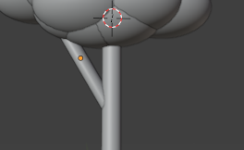

Copy this branch and then make it more around the trunk

Now make it look like below

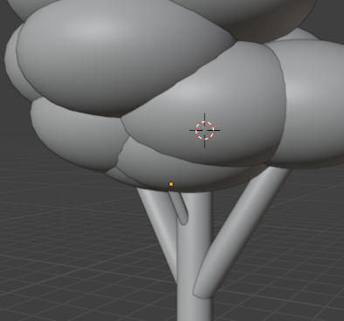

Now our tree will look like above

Now our mesh will look like a tree as shown below

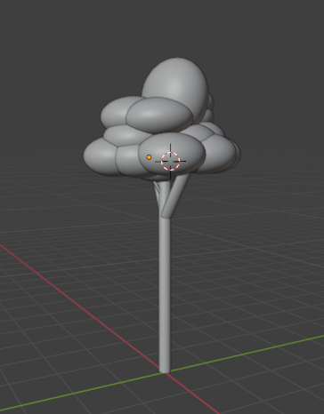

So now I want to make this one object.

So I'm going to just with the select box on the toolbar enabled up here and click and drag. And make rectangular shape so that it cover all the tree sphere and the branches and trunks. And if I join this right now, you'll remember from the lecture that the marked one will be its new pivot point,

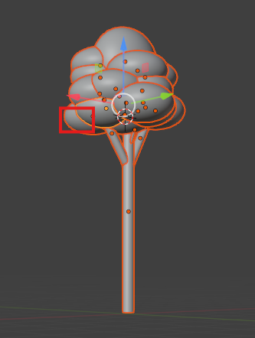

As it is selected active. which is not really ideal for what we want because we're going to want to move this around next.

So with all of these selected, if I just hold shift and press the one that I do want to be active ( means make the active selection ) we want to make the trunk so we do it active selection

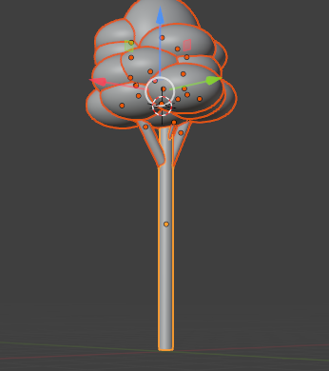

Now you can see below that the trunk is actively selected



And now we can just press **ctrl J** and now you can see now it is a complete tree

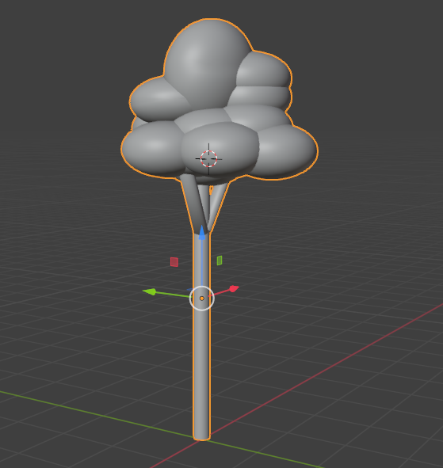

Since the trunk name was cylinder and it was actively selected. So tree is named as cylinder in the outliner as shown below in the ourliner

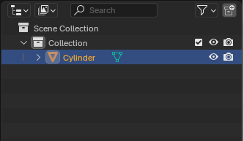

And now we have a whole single object, so and it move it around, it moves all together. We rename it to tree. Now in outliner you can see tree is written

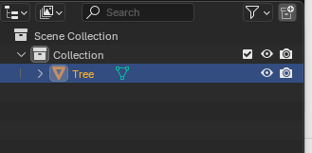

Now, trees rarely grow alone, so let's move it along the ground here. And we're going to start duplicating it by pressing shift + D. We're going to rotate one of the duplicated tree around the Z access to give it sort of a more random appearance. They don't all look like exact copies of each other, even though they are. We're going to make them slightly different heights. We're just going to repeat that process until we have. Nice trees growing in sort of clusters the way trees do.

Because the pivot point is in the center as shown below. When I scale them up and down, they kind of shrink away from the ground

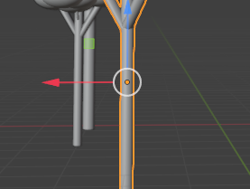

We'll go over how to move a pivot point in a future video, but for now, just place them back where they need to be.

The 3D cursor can be really distracting to you. So we can go to viewport overlays as marked below in top right corner

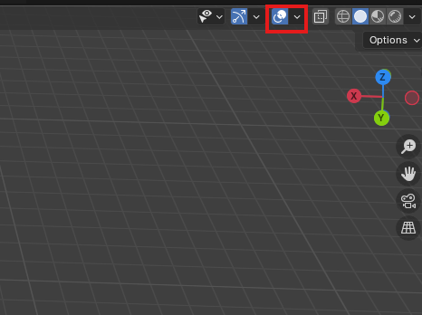

Now when you click on the marked above and then in the submenu uncheck the 3D cursor

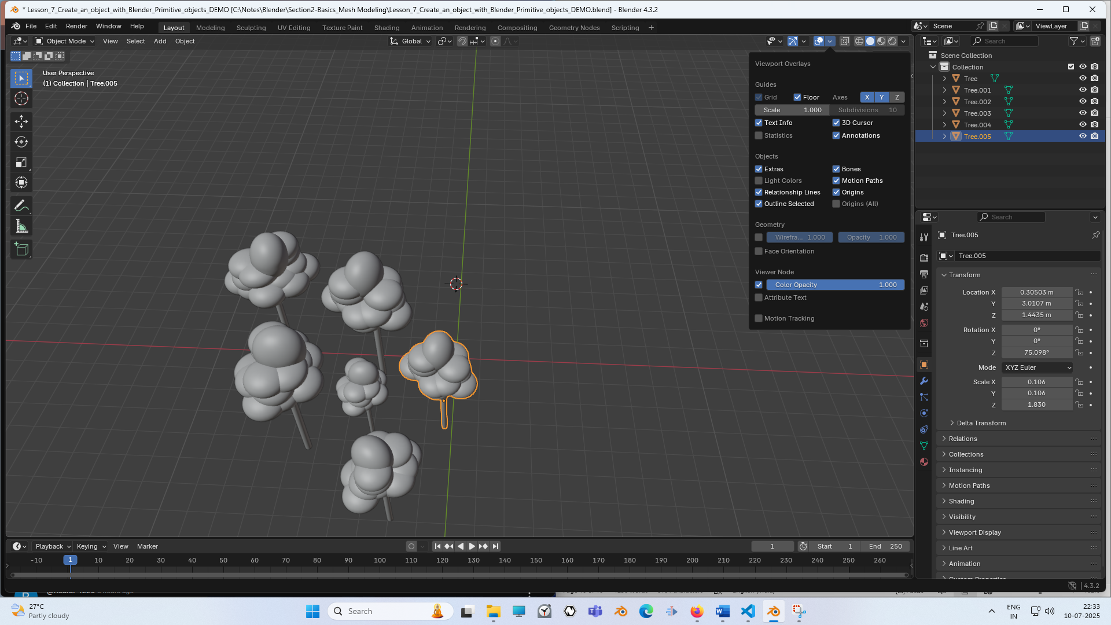

And it will be hidden in the viewport.

10:00

Teacher recommend having it on in the beginning though, because you might get confused why your objects, new objects are being added way out into the distance because you've accidentally shifted right click Let's put an actual ground for them to sit on so they're not just sort of floating onto this grid. So we are going to add plane by shift + A > Mesh

Now scale it along the x and y so that it will become a platform as shown below

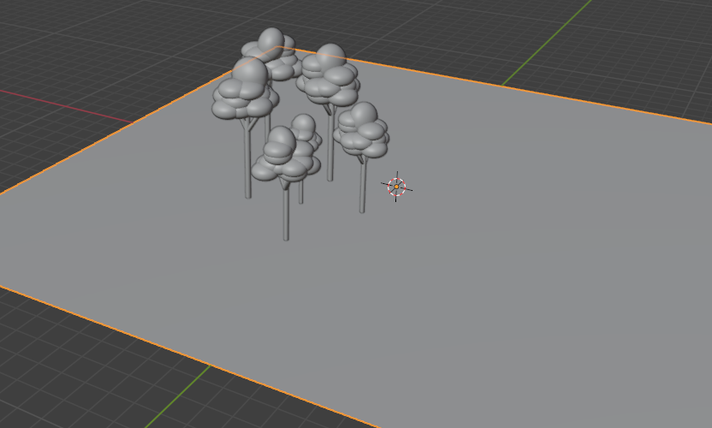

Now it looks like they're actually sitting on the ground. All right, we add next let's add some like Teacher don't know Bushes. We add a sphere as shown below

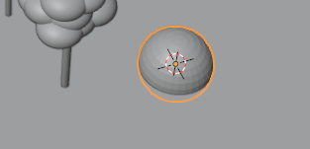

You ca see when I hit numpad one to go and up front with a graphic, the plane disappears as shown below.

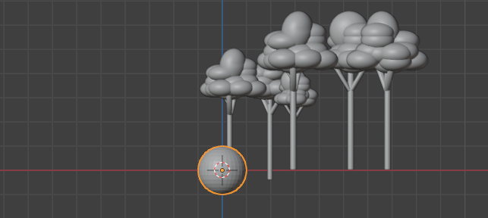

It's just because it has no thickness to it. So when you're viewing it exactly from the side as shown below



you can kind of see it this line as shown above because we're still in perspective, but it's just because there's no thickness. So you're just viewing basically a two dimensional line. When you go exactly into orthographic mode, it's still there but hidden as it don’t have thickness

Now shrink the ball along z axis so it will be like marked below

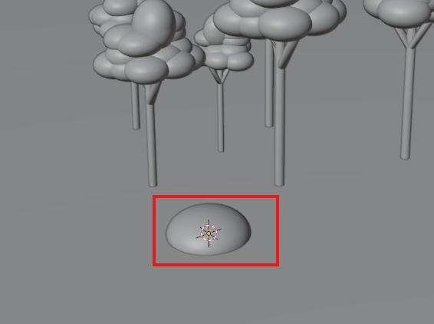

Now duplicate it and overlap each other and make it like a shrub. It is probably not the most convincing shrub we’ve ever seen as shown below, but we think it gets the job done.

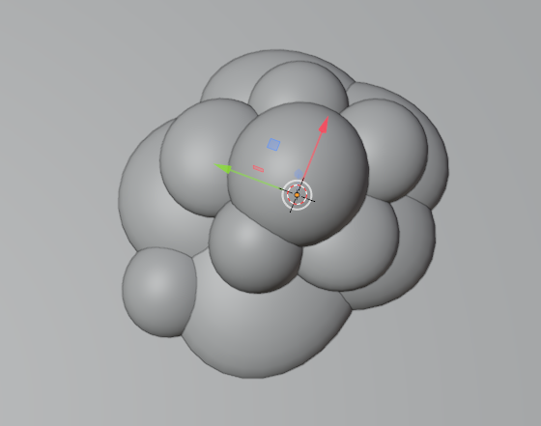

Now we will make it a single object by ctrl + j Now when we select it. It mistakenly select the plane so we hide the plane as shown below by selecting the plane and press H

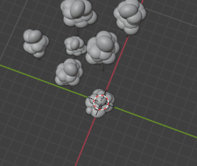

You'll see it kind of goes dim here in the outline here as marked below

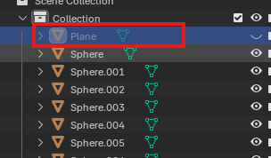

Now we can box select all of these. The plane will not be selected. Can choose which one we want to be our active by shift + click on it

Press ctrl + j to join Now it will be like below

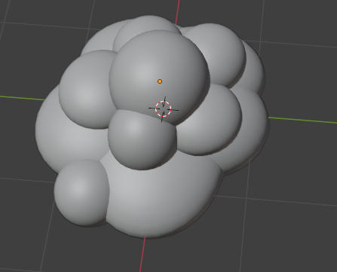

We rename it to shrub in outliner as marked below

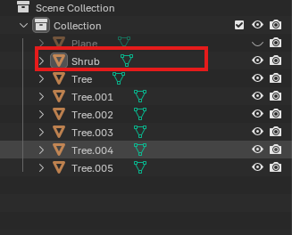

And you will see what we had named the tree after it get duplicated then name is maintained with the numbering suffix across all of these duplicates here

We unhide the plane and rename it to the ground

Now make the shrub slightly smaller and duplicate it and rotate it to create its different variation as marked below

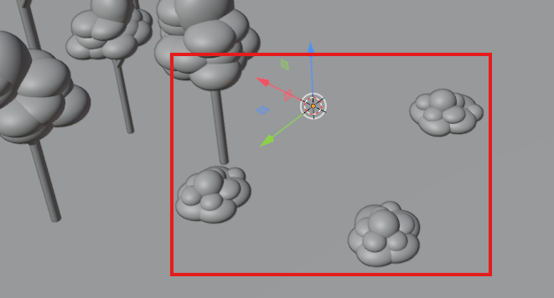

14:10

**If we move an object and lock z axis while moving then it will move in the plane it was before it was moved**

**Since the platform align with the plane of shrub it is in so when we duplicate it and it by default move then if we lock the z axis then it will move along the platform. If we don’t do it then when we move then the shrub or any mesh object will move up and down the platform when you move**

To make our trees look different you can make them scale along an axis

it allows us to get a lot more variation in these objects without having to actually model completely new ones.

Now we added ICO Sphere by **shift + A .**And we also added UV Sphere by **shift + A** as shown below

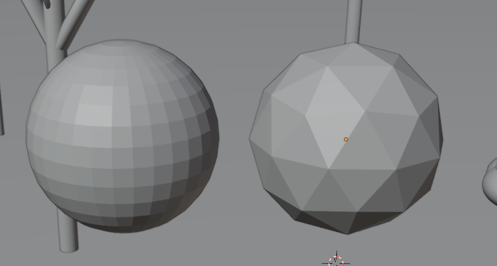

The right one is Ico Sphere and the left one is UV sphere

Now there is difference between them is that right one is Ico Sphere and the left is the UV Sphere

Ico Sphere has a triangle faces and UV sphere has a square faces And we'll get into why this matters a little bit more later on. But it just it just gives it a sort of different look.

So when using the UV spheres up until now, because I wanted these to be pretty smooth, but if I'm thinking like rocks, you want it to be kind of jagged.

So using only the skills that we've learned so far, Teacher thinks an Icosphere can make a better rock.

So we delete the UV sphere

And then made Ecosphere something like below and attach it to the platform

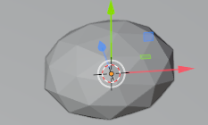

And now add another EcoSphere and now they will be like below

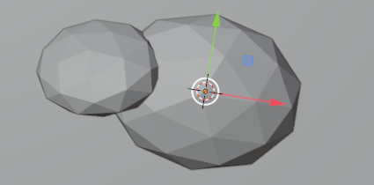

Now we group them and we name it Rock we can duplicate it and use its upside many variation like scaling it and making it upside down

Now our screen will look like below

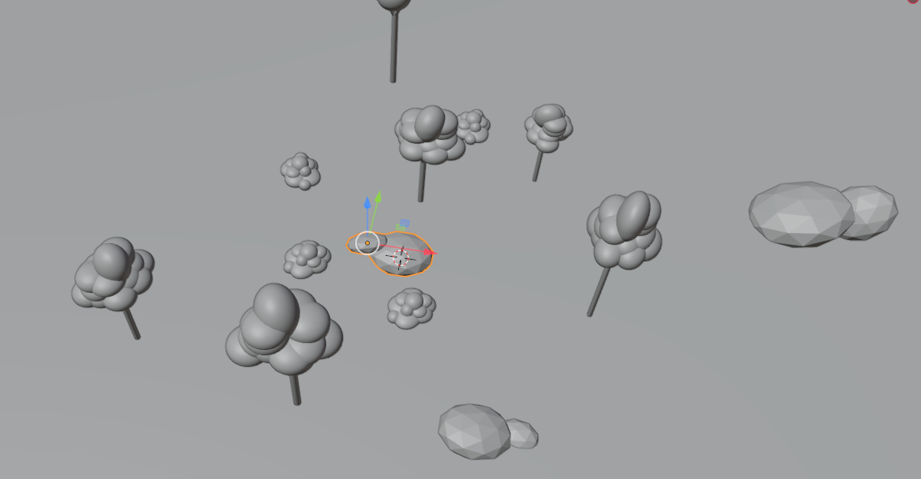

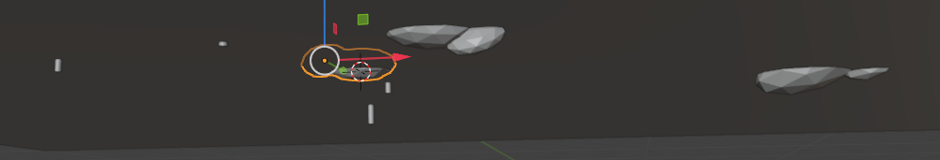

You'll notice for these rocks, especially, we are letting them just kind of stick through the ground. That's another good reason to have a plain is that you can use the plane essentially to hide all this stuff. So with a single rock model, we can use the transform tools to really get like a wide variety of different looks from the same what is essentially the same piece, a trick of use a lot, especially like in games where you'll have, you know, you don't necessarily want to model a hundred different types of rock, but you may need them all to look different otherwise it just looks strange in the scene. So, you know, you make three or four rocks and you use your transforms and you clip it into the ground. So they appear to be different even though they're the same.

Now we add some cube to make some sort of buildings

Now our scene look like below

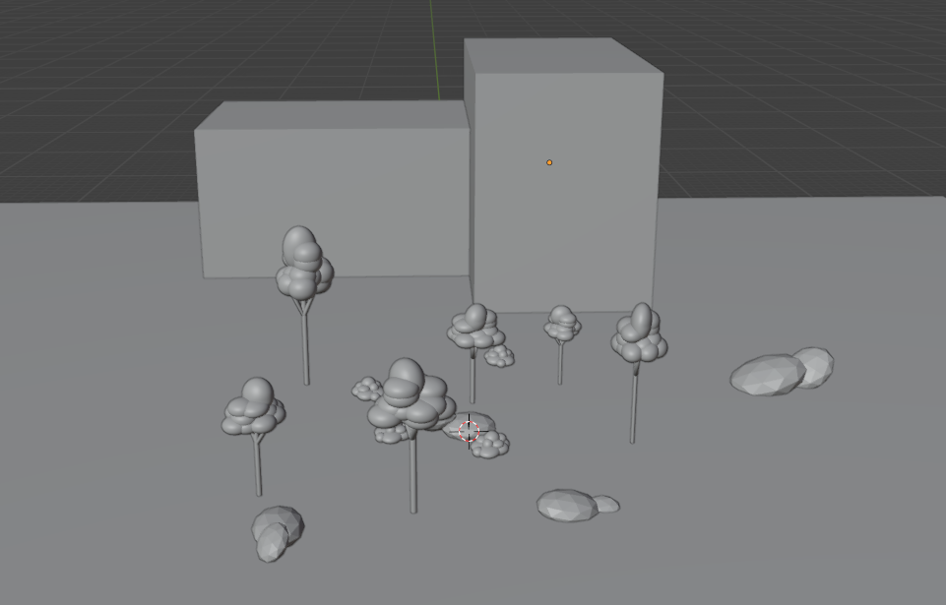

Just make it a little bit more clear that it look like a building so now you can add some more meshes to represent like windows and doors and things like that.

19:27

So we add a cube and make it something like below and attach it to the building so that it look like a door

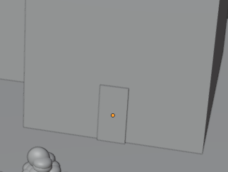

This isn't really how Teacher would construct a building unless I was going for this visual style really specifically, but using only adding and transforming objects.

We duplicate the door and then add it like a window but make the duplicated door little bit shorter as shown below Now after some modification the building will look like below

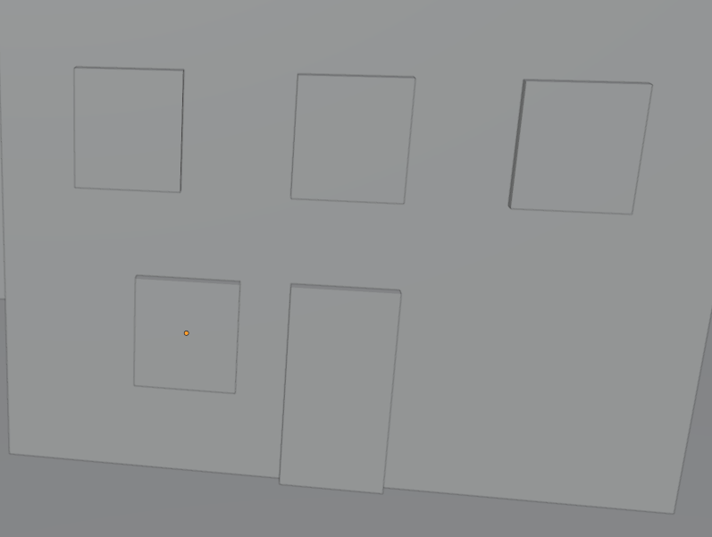

The bottom left side door usually align with door in real life (according to Teacher)

Now we add a doorknob to the door just to give it a little more definition so we add a sphere and make it like a doorknob as shown below

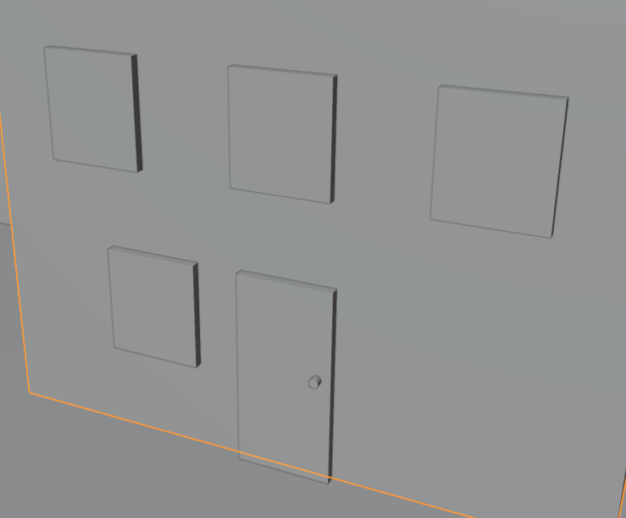

It is okay if your meshes get intersected each other that’s totally fine

In the doorknob we add a sphere part that is usually added to a door knob in real life so we add a sphere to it and modify it and now the doorknob look like below

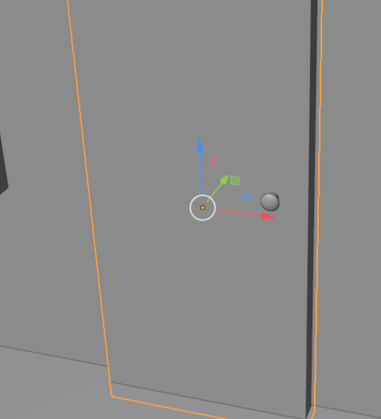

We make the door thinner , since we don't know how to separate parts of a mesh from each other yet, just make sure everything is really where you want it before you join objects.(who knows).

We join the doorknob and door. We're going to go over how to separate like these pieces from each other once they're already joined. But that's for a future lessons here. Now we're just practicing, adding and transforming. So we are just going to undo until they are separated. And then we shade smooth

(When I have a smaller piece selected, the camera is rotating around my selection and this is something

London does just by default.

Have you ever wondering why your camera's not rotating the way you want it to?

It's probably because you have something selected that shouldn't be for your purposes.)

But this does not happen by default (but not happening with me I think this feature has been removed))

Let's give you some like window like frames so that they're a little more easy to see in our scene.

Now our window beside the door look like below

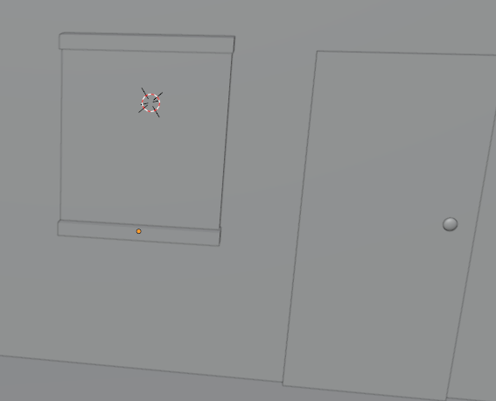

These aren't going to be very exact because we're not actually into editing individual meshes. But again for purposes of practice and demonstration, this works just fine. But we definitely can make these more exact. When we know how to do more in blunder.

Now we add a vertical frames Now it look like below

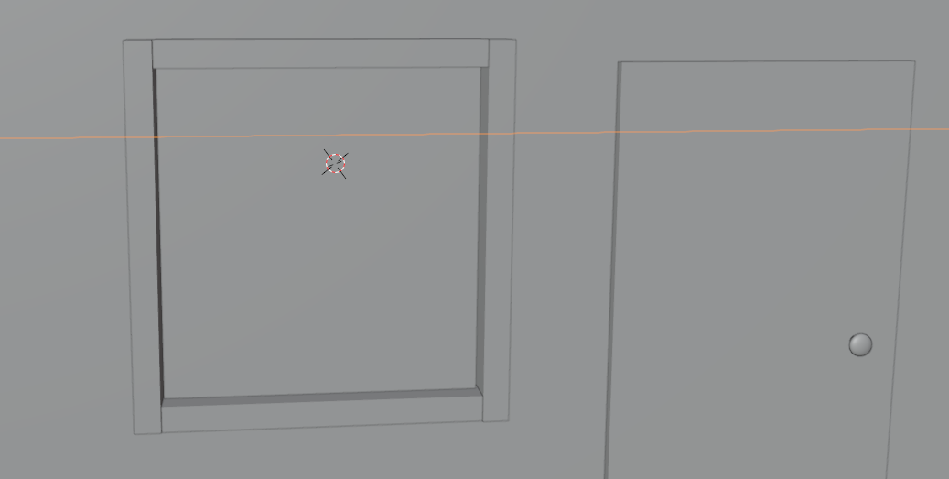

And now from side it will look like below

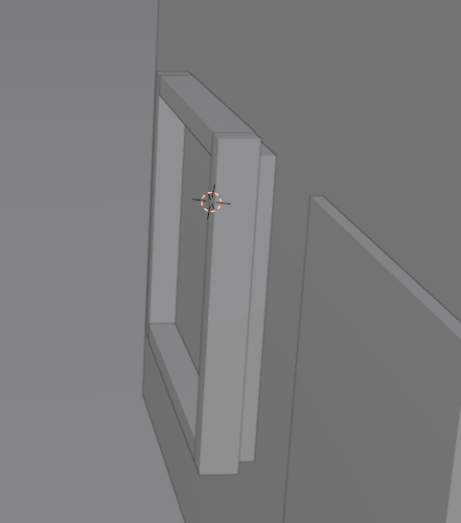

To make it like above Make the frames come forward.

25:40

So we will see if the two faces are occupying the same space Blender does not know how to draw them

So you will see this sort of flickering happening which we call it Z fighting but it think in newer version it does not happen

It just means that you need to offset these slightly( seperate these plane ) because two objects cannot locate the same be located or in the same physical space. It just doesn't make sense.

We make the highlighted object thinner as shown below

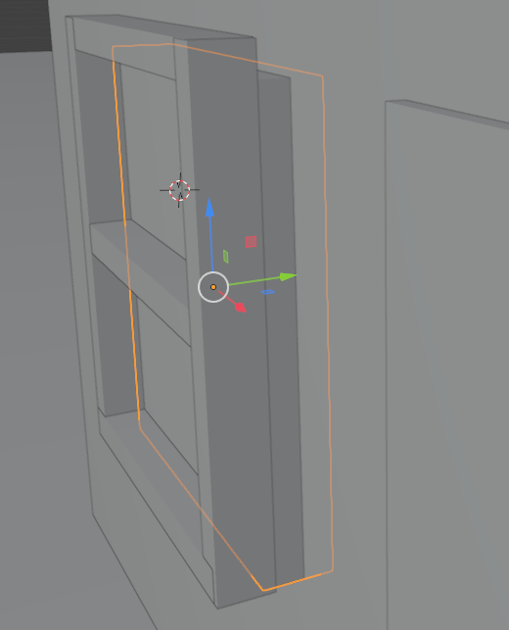

Now we make the vertical frames and then attach it to wall Now our window will look like below

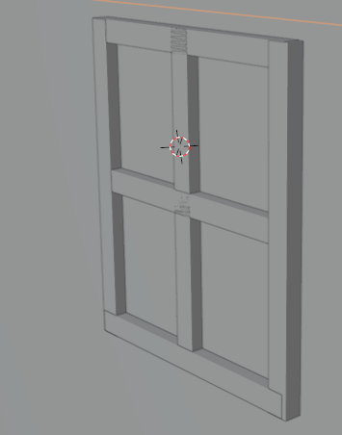

Now one thing you notice is that there is z fighting happening as shown below in the intersection iof vertical and horizontal frame as shown below

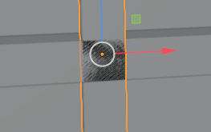

So we make one of them slightly lower so that there will be no z fighting

Now you can see the window shown below there is no z fighting now

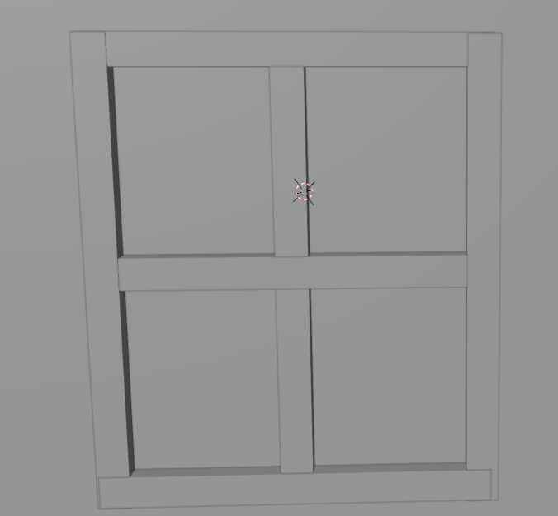

Now we join them and make the background part of window as the main object for joint

After joining it will look like below

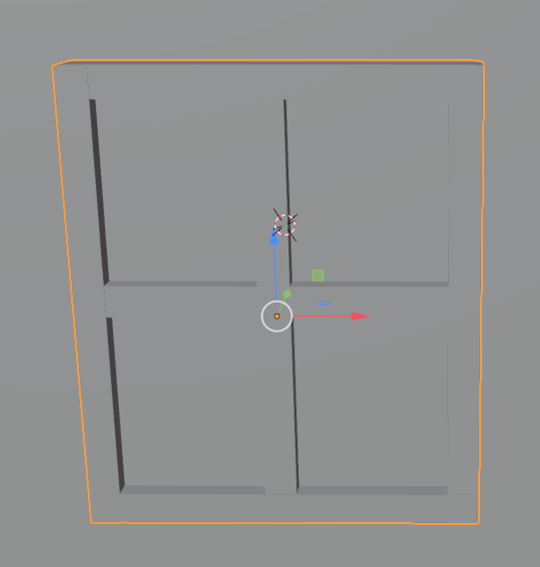

You can also view the inside of this building now or any object. Just zoom in the object and move around you can see its insides as I done it

Now inside house it looks like below

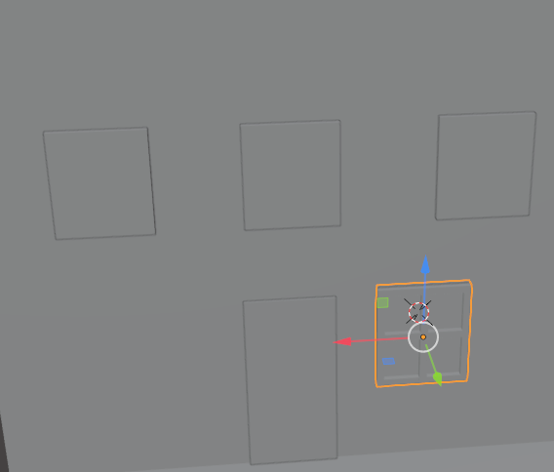

Now we remove the other three top windows as we don’t need Now building look like below

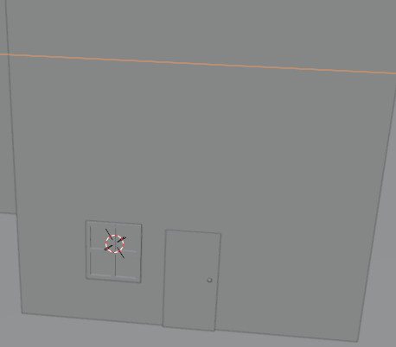

For a quick note you will see the in orthographic view front you really can’t see any these little panes and frames that we have added any more And that's just because it's having a hard time showing you in this mode, because this face is perfectly flat and you cannot see its horizontal edges so you cannot distinguish them from other things So it's the same principle as viewing our cube from orthographic mode. We can no longer see the sides of it(the window).

So from front it is hard to see what you are doing as shown below

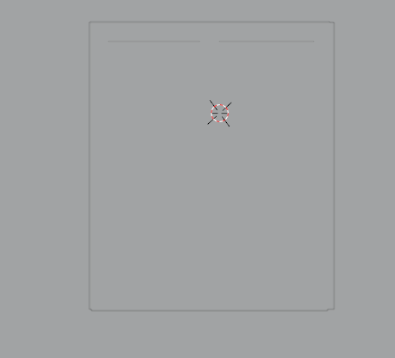

You can go to top right there of the viewport and you can see the view mode as marked below

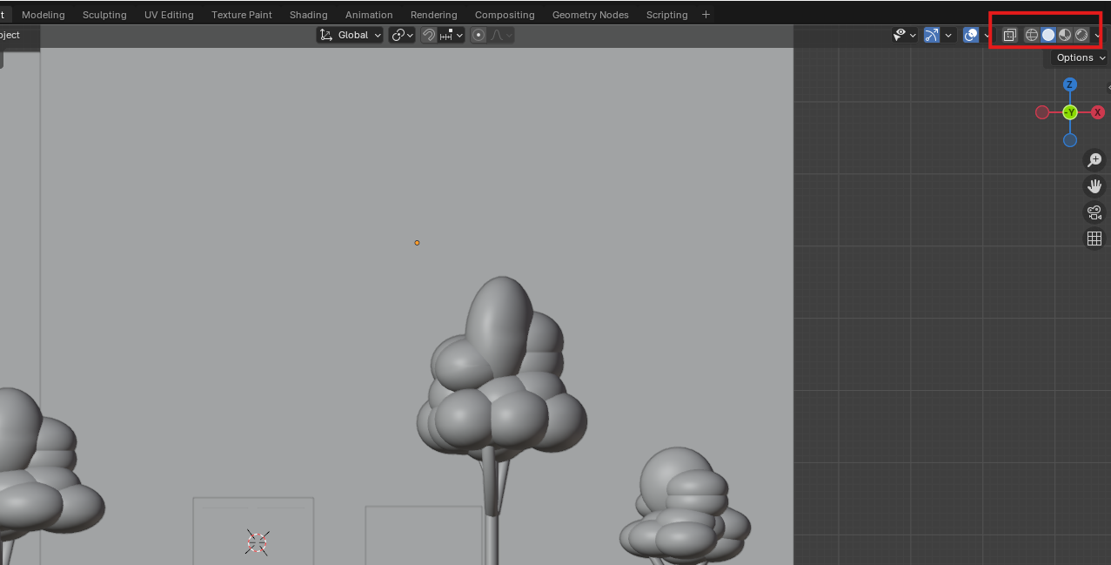

And we will talk about it later in the upcoming lesson

We are currently now in solid mode, which basically is just going to render everything here as this sort of flat grey color which makes it hard to see when you are dealing with lots of objects that are overlapping each other (maybe when you see it from a particular orthographic view) So in order to get a little bit clearer picture, we're just going to hit the dropdown in the side of viewing modes here as marked below

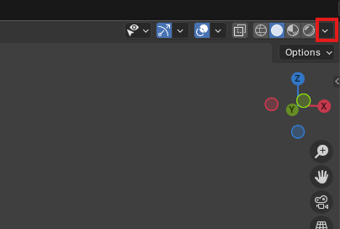

And then in submenu there is option called cavity check its checkbox to enable that to and there is pretty slight difference and the

Before cavity The window look like below

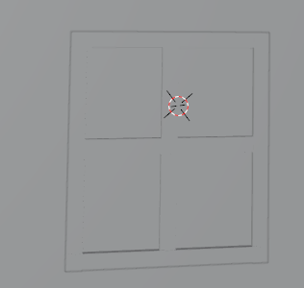

After cavity it looks like below

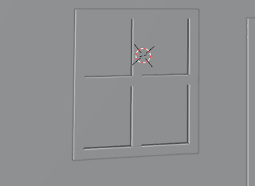

it's a pretty slight difference, but it sort of just draws black into these inner sort of shaded areas (maybe especially those who are perpendicular to the outer face)and it draws a white edge along these outer edges. And it just enables us to see it a little bit easier.

Now we duplicate the window and set it on the building I did it and it looks like below

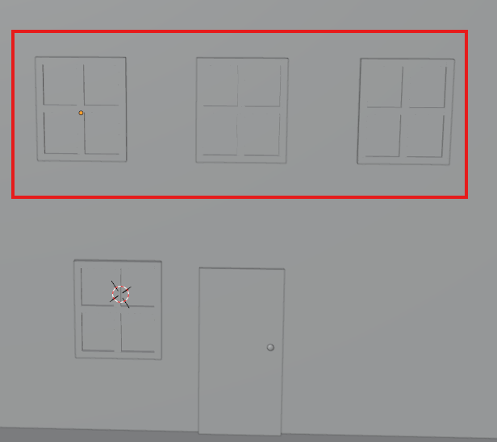

You can also duplicate more than one object at once with just all the objects you want to be duplicated selected. Same thing as duplicating a single object. So we duplicate all the three windows as marked above by selecting all of them and then press shift + D and then move it around Now after I make it look like below

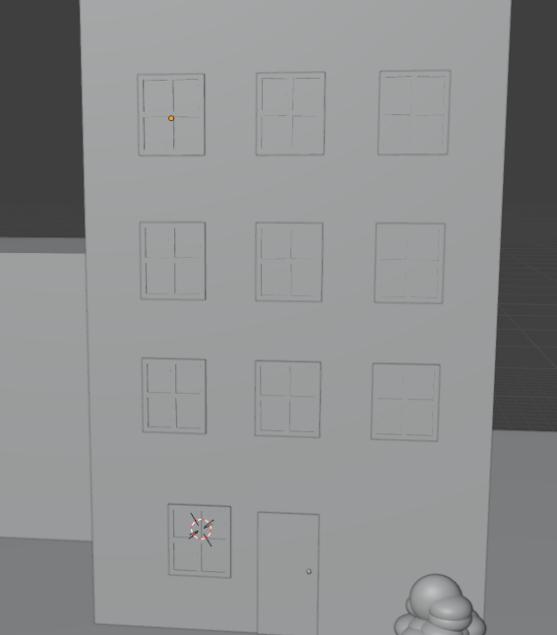

Now duplicate the door of the building you see above and now paste it in the second building

Now after scene look like below

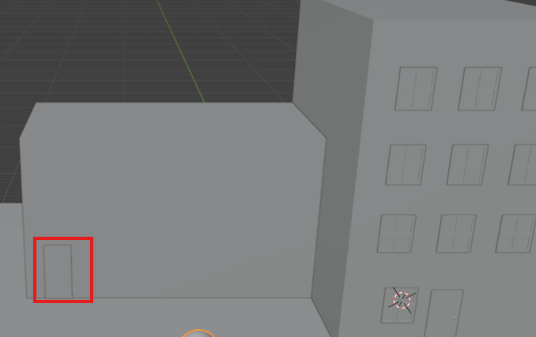

The marked one is the duplicated door we duplicated and attach it to the other second building as shown above

29:55

Similarly we add the window on our second building as shown below

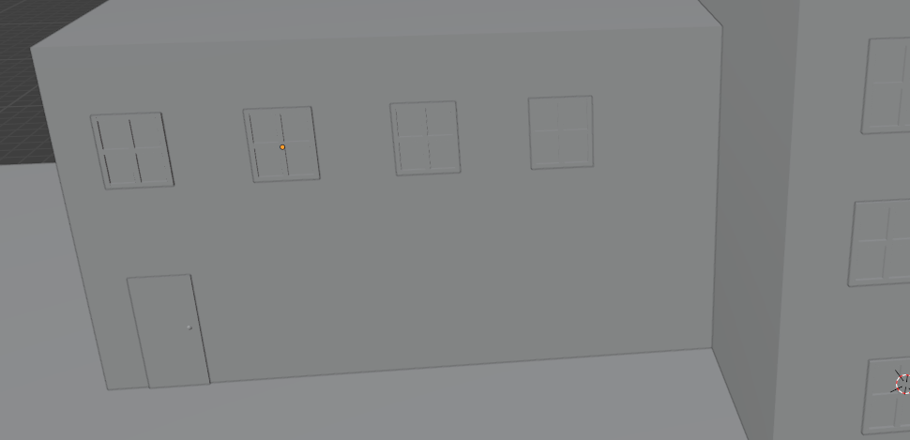

Teacher is not just eyeballing these placements and not using any sort of exact measurement at this point.

Now we can add some stepping stones or path along the door of the main building

Teacher is thinking to make it with IOSphere tpo match the rocks we made or a cylinder to make it more like pavestone. This is just largerly a personal choice of the design. You want to stick to

Teacher add an Ecosphere in her design We give it a faceted look as shown below whereas the cylinder tops(If chosen) will just look quite flat

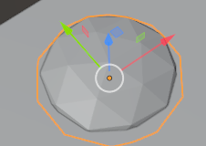

Now we add some rocks and make a path way as shown below

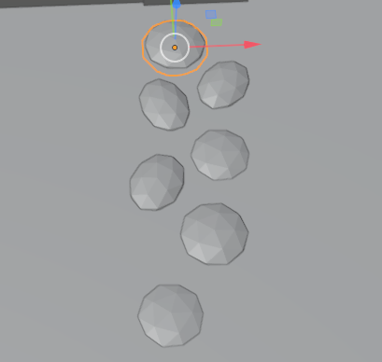

The teacher is saying that in outliner folder come in handy As we make objects we start to forget there name but we will start to organize this scene so that we can more easily manipulate these object as we need them

So now in outliner we shrink our main collection as marked below in the outliner

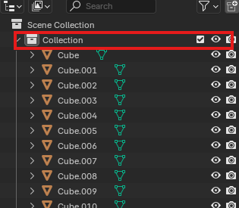

And now the outliner will look like below

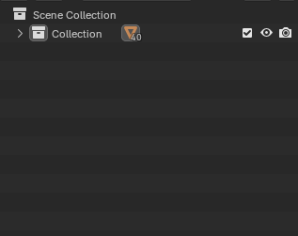

Now right click on the empty are and a menu will open click on new collection and then a new collection will be made and we rename it Tree as shown in Outliner below

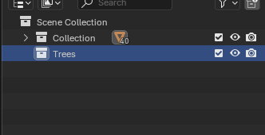

We are going to put all the tree objects here in this collection

So what we can do is that we find all the trees in the scene and select all of them and drag and drop it on the tree collection.

Or you can select all of the tree in your scene and then we can hit **M** on keyboard

32:30

and then a small temporary window will open showing list of collection where you want to move Now select the collection where you want to move your selected tree or click on new collection to create a new collection and move all the selected object inside it after clicking on new collection name it and then the collection will be created along with the selected object inside it

Now Our tree collection contains all three trees in the scene as shown below

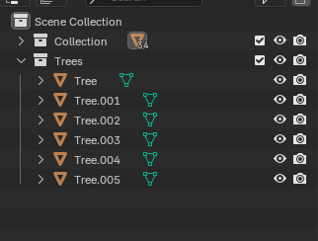

Now all the trees are organised into one collection If we are trying to like kind of We add something las marked below

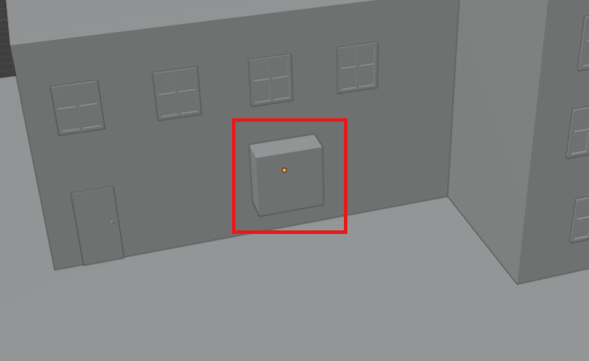

Teacher is trying to like kind of make it like a garage door or something like right here if we go into orthographic view in front then there are many things coming in front of us as shown below

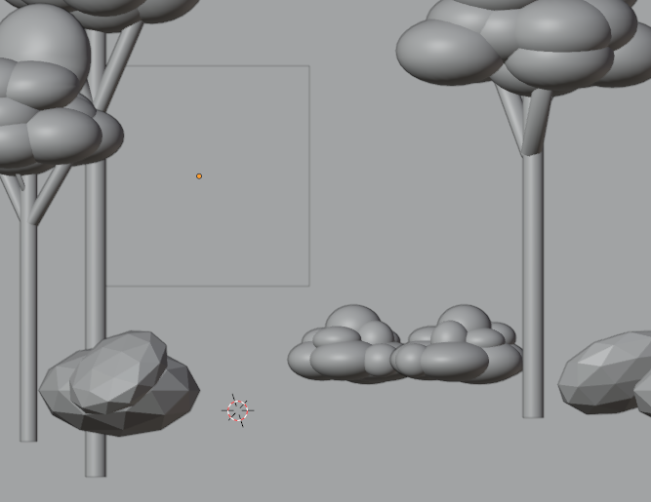

The mainly are trees so we are going to hide them by selecting the component and then press h to hide that collection

We hide the trees collection now it look like below

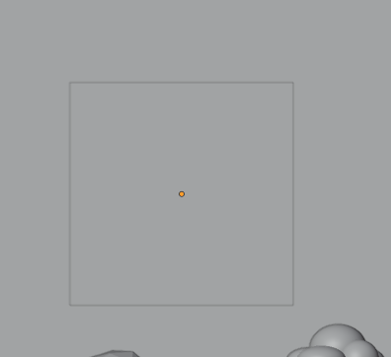

Now we are making other objects added to collection we make one for shrubs and add all the other shrubs inside it and also hide them make one for rocks and also hide them Now our outliner will look like below

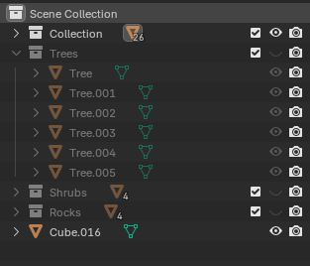

Like teacher mentioned before, no two objects in Blender can have the same name. A program just can't handle that. So if select one window as highlighted below which currently is named cube006 we name it window

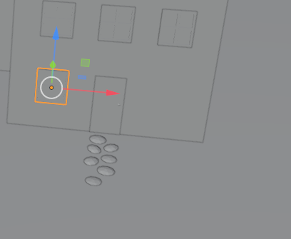

Now we rename another object and name it window now it will automatically add a numerical suffix after it as shown in the outliner as marked below

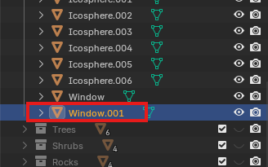

because it recognizes that there's already a window in the scene.Now we name other objects which are window shaped window. It would have been easier if you have already renamed that window shaped object to window and then had duplicated it But we forgot about it. Now we have to pay

Now we make our door shaped objects named as door and now we make the Building shaped object as Building and they will be named as Building<numerical suffix>

35:00

Now we name the stepping stones looking objects as stepping stones and repoective suffix will be added to them

Now everything's named and organized as shown below

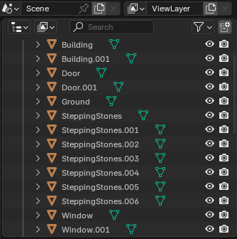

Now everything's named nicely.

Now we name the highlighted below as Garage

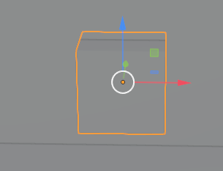

Now scale it and make it look like below

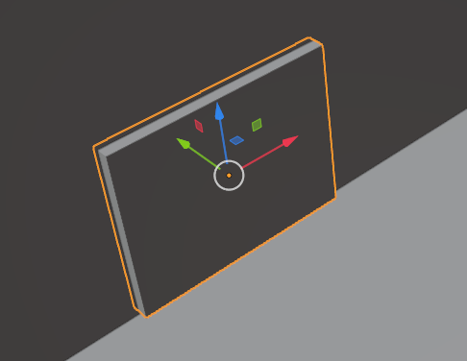

Now we will move this garage object outward look like below

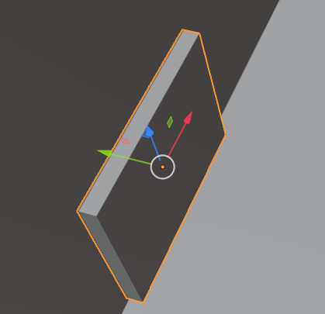

Now we again scale it look like below

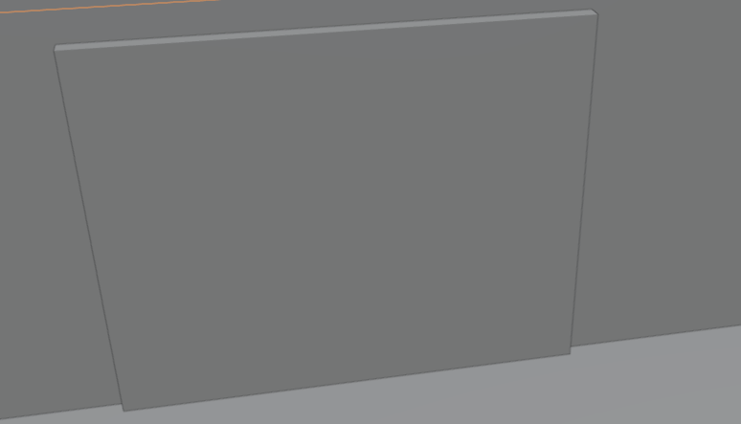

Now the buildng we made kind of look like dull so we can just add a little bit more definition by adding more cubes to it. So rather than adding a new cube because we want(who knows) we're going to add some like columns and things to just make it more, a little bit more defined.

Teacher think its easier when we have already have an object with similar dimension that we want then we can easily duplicate it (who knows)

37:13

Now we duplicate our building and by scaling and modify it such that it will become like marked below

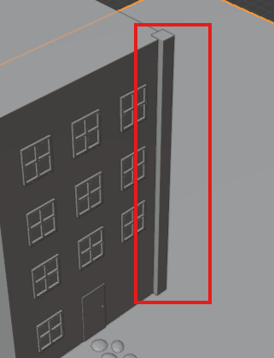

Now we name it column

Now we duplicate it and place it on the other corner of the building as shown below

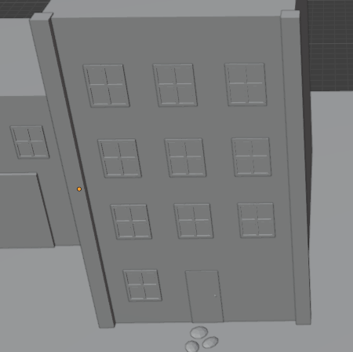

You can remove the z fighting by covering it something other object or it cannot be viewed from a certain camera angle and it depends on you that do you want it or not if you want it then its totally ok to leave it

The best thing teacher like about blender that it also undo your latest selection when you press **ctrl + z**

39:05

It’s really nice as a lot of programs don’t consider selection to be an operation That way the blender does.

Now like we added the column in front side we will add it for the backside as shown below by duplicating and now it looks like below

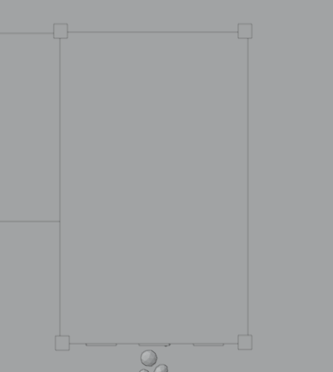

**Top View**

Now we also add a horizontal column as shown below

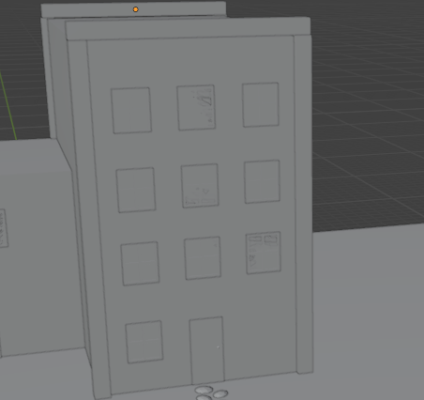

Now we also add it at the backside of it by duplicating the horizontal column in front as shown below

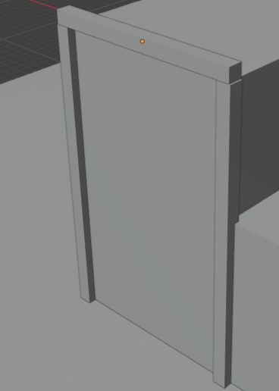

So you must have noticed that the way we are doing these, I'm duplicating it and then I'm lining this orange dot in the object that is our pivot table like below

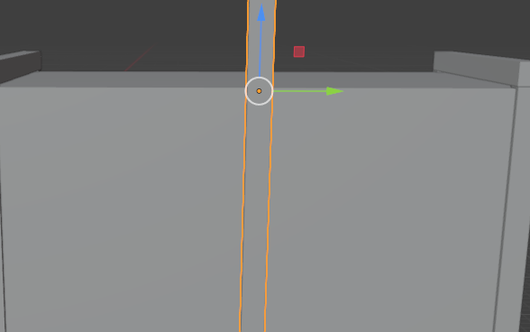

So at this point, it's never going to move based on a, you know, a rotation operation or something like that.(maybe so that when it will be rotated in 90 degree so that it will align the top surface )

Now after modifying it and then rotating it to 90 degree now it will look like below

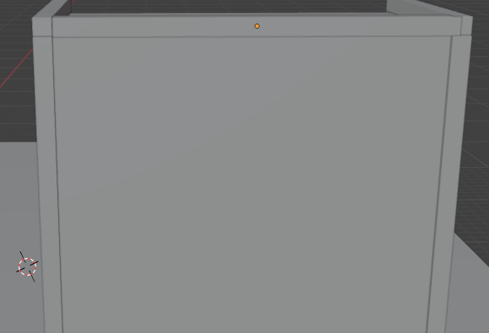

Now we duplicate it and then in another side

Now it will look like below

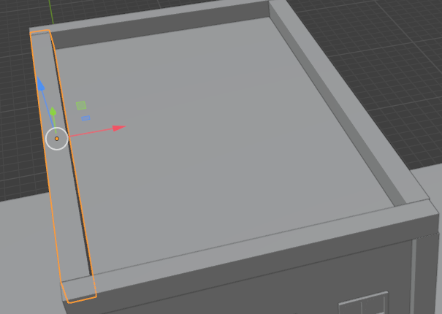

You know it look like apartment building as shown below

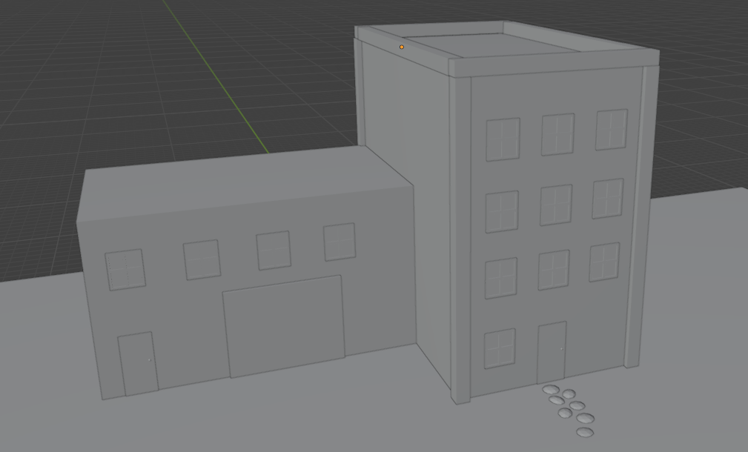

Whenever you are making a model and I depends on the scene you are working on Teacher tend to find it easier to model things on the origin point because it's just sort of a default and it makes sure you don't have any sort of wacky values in here. in out N popup as shown below

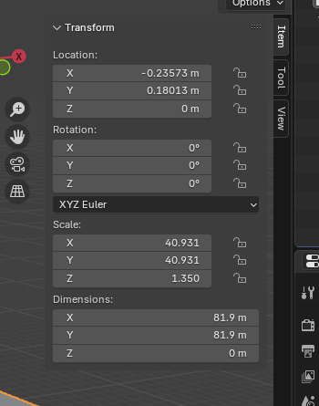

Teacher find it easier to model things and then move them, but you are totally welcome to model them in place. It is just a matter of personal experience Now we model something look like below

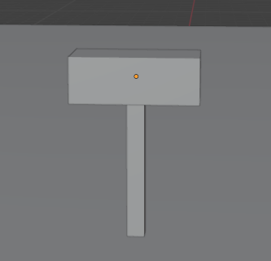

42:05

Now Teacher says if you select multiple things and then you can perform operation on multiple things at once.

Now we add another component on the mail box .Now we add another parts on the mailbox by modifying cube Now our mailbox look like below

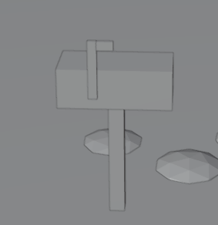

Now we unhide everything Now our scene look like below

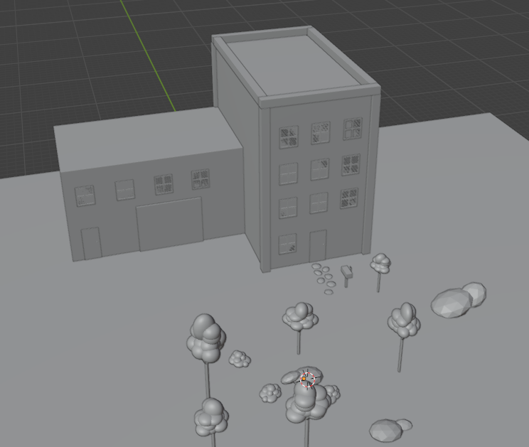

43:16

Teacher feel like we started out with more of a nature thing and this building doesn't really belong there. So let's reconfigure some of these things to make it look a little bit more cohesive as a scene.

Now we delete the plane that represents the ground and in place of that we add a cube in the center and then flatten it out (It is just a design thing )and then make it below the scene look like below

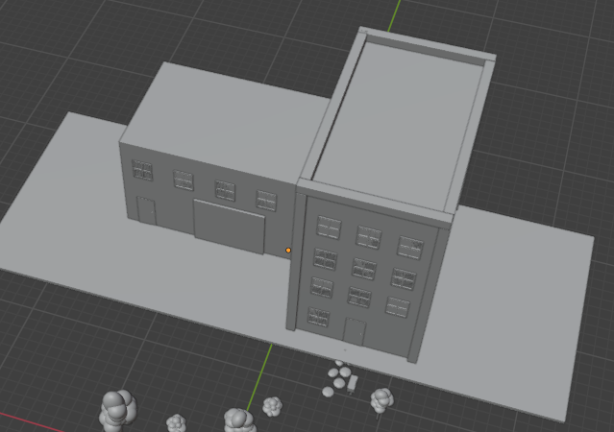

So instead of like having just a flat ground plane, this is starting to look more like a city building and not like you know a small house Make this more like on a sidewalk. By adding trees on one side as shown below

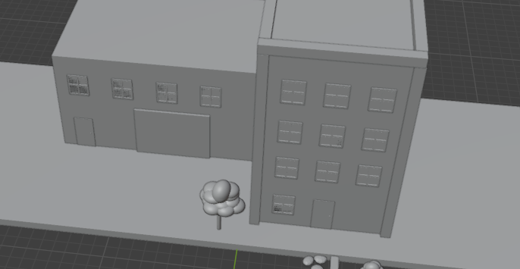The trees are like just the little city ones you know, have poking out of the ground, sometimes out of the little holes in the sidewalk. This is just a composition A tenant would not want a larger object to be placed in front of the house as it is obstructing the view so we place a small tree in front of the secondary building Now our scene look like below

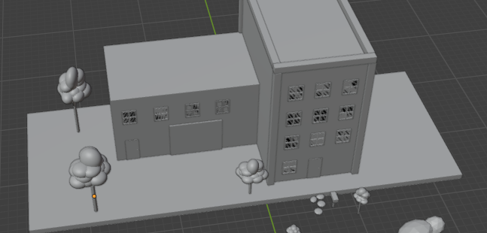

45:52

And we also we want to make sure that like these trees aren't perfectly aligned when you're viewing it from the front. As shown below

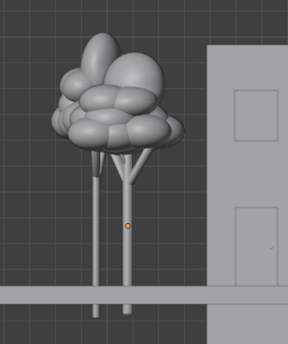

Just because when you view it from the front, it looks strange. So this offset it a lot. So, you can tell that there's two trees there. Obviously, if you know the camera angle at which you're going to be viewing this at, if it's not enough for a game or something where it's live demoing(wo knows), you know, you only have to model and make objects for that camera angle. But this is just more sort of a general model(who knows).

So we're going to make sure it looks good on multiple sides.

So we add a tree on another side of the building as shown below

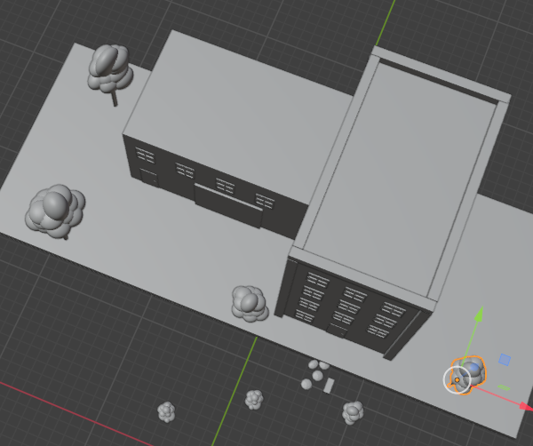

Now we don’t need teping stone so we remove it by del and we merge our mailbox as shown below

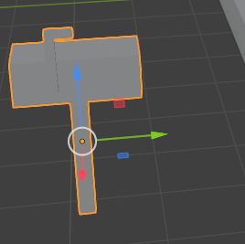

Now we rename it to MailBox in the outliner as shown below

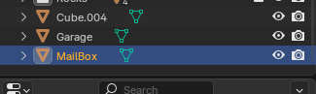

Now you'll see that the objects I added are added outside of a collection. This is because we weren't in a collection, we didn't have one highlighted when we added it.

**Note:-**

So when we added an object and a particular collection is selected in the outliner then new object will be added inside that collection.

47:16

So it just added it to the general scene collection. You don’t have to put your objects inside this folder but it is really handy way of organizing it we move it to the collection you want it to be in by dragging and dropping it in the outliner Join it and make it like below

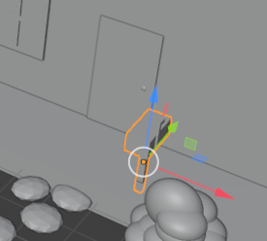

Now we increase width of the land and move out mailbox like below

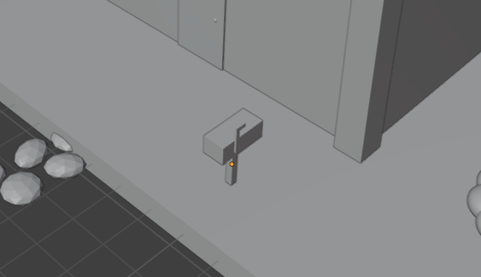

We name the floor as Sidewalk and move it to the collection

Now we duplicate the sidewalk object and then move it in y axis and extend now scene look like below

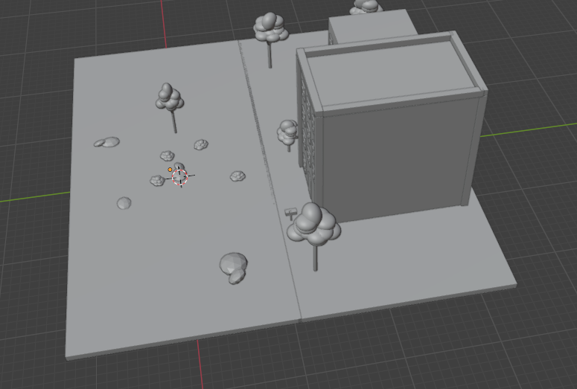

48:37